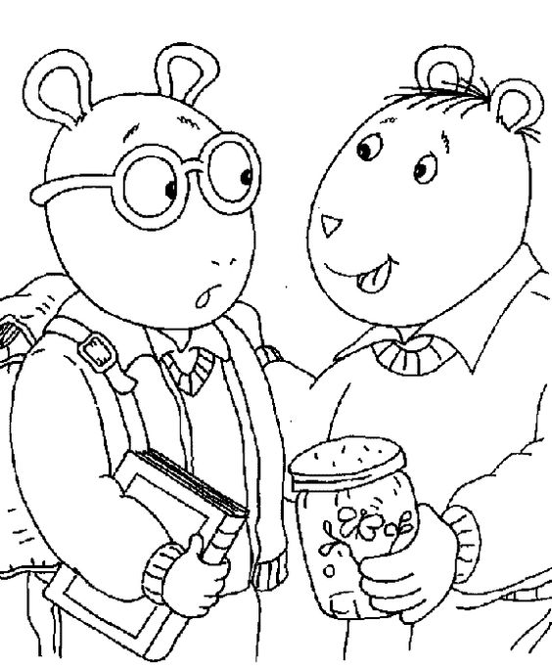
Be a Good Listener to Everyone You Meet.

