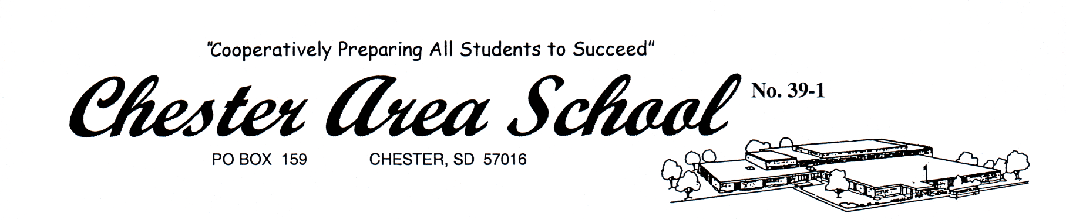

Chester Education Association Scholarship

Deadline: March 29, 2019 – To Mrs. Hansen

The Chester Education Association Scholarship will be awarded to at least one senior who is seeking a four-year degree in the education field. This scholarship will be awarded to the applicant who embodies the characteristics and enthusiasm of an educator.

Name:
GPA:
Class rank:
Anticipated major:
Post-secondary institution you will be attending:
Number of days tardy in senior year:
Number of days absent in senior year:

Please write an essay (maximum 250 words). Why do you want to be a teacher?

