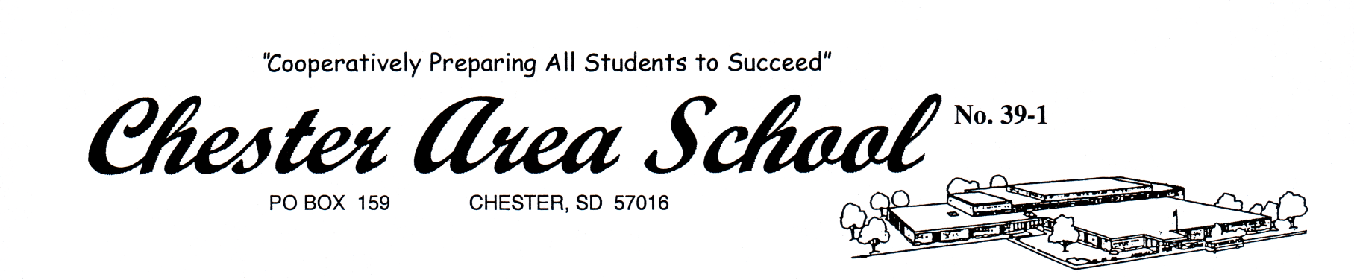

Chester Centennial Scholarship

Deadline: March 31, 2020 – To Mrs. Hansen

Scholarship(s) will be awarded to at least one senior who will be attending a two- or four-year technical school, college, or university in South Dakota. These students also have a desire to be a leader in the community he or she lives in.

Name:
Post-secondary institution you will be attending:
Major (if known):

Please write an essay (one page). Why is your involvement in the community you live in important? How will you give back to your community when your post-secondary training is finished?

